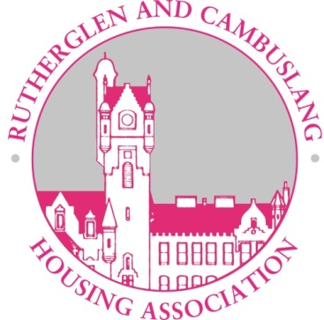

HOUSING APPLICATION INFORMATION
Please complete every section of the application form – if you are unsure about any aspect of the form please call our office to clarify any issue. Documentary evidence of your current residence should be provided with this form. We require the name and full address of your current and previous landlords for reference purposes.
If you have a medical condition please request a medical form and submit this with your application paying particular attention to the section on the ability to climb stairs and please be specific about any adaptations you require to the property.
Your application will be processed and will attract points based on the information you provide in the form. These details will be verified at a home visit prior to any offer of rehousing being made to you.
The attention of all applicants is drawn to the declaration on the application form concerning false or misleading information. If it is established that false or misleading information has been provided or relevant information with-held, this may lead to the application being suspended for a period of 6 months. The Association will make enquiries to verify information provided. If a tenancy has been offered, the offer will be withdrawn. If the tenancy has been taken up then the Association will take legal action to re-possess the property.
EQUAL OPPORTUNITIES
Rutherglen & Cambuslang Housing Association is an equal opportunities organisation and will not discriminate on grounds of race, colour, culture, ethnic or national origin, religion, gender, age, disability, sexual orientation, family circumstances or marital status in the allocation of our housing stock. The Association allocates all properties in line with its Allocation policy and no other factors are taken into consideration in this process.
ACCESS TO WAITING LIST
The Association has an open waiting list and invite applications from households over the age of 16. Priority is given to applicants who demonstrate an element of housing need as determined by our points system. The issue of an application form should not be taken as an indication that a house will eventually be offered to the applicant. Anyone applying for housing who has a zero points allocation will not be held on the active list but will be held on the deferred housing list and given appropriate rehousing advice by staff.
Association staff will discuss housing prospects with applicants, assist in the completion of forms, and will provide details of other housing providers in the area (Please see additional leaflet). The Association will provide a sign or language interpreter, or any other representative requested to assist the applicant in completing an application and documentation can be provided in other formats if this is of assistance to the applicant.
To ensure fairness we allocate from the following groups on an annual basis; 40% of Applicants from the Association’s Waiting List, 40% of Applicants nominated from South Lanarkshire Council, 10% of existing tenants of the Association(providing there is housing need) 5% of existing tenants of the Association(wishing to move on aspirational grounds), 5% of referrals from other agencies e.g. Social Work Dept.
SIZE OF HOUSE WHICH WILL BE OFFERED.
We will not normally offer accommodation where overcrowding or underoccupation would occur.
NUMBER OF OFFERS WHICH CAN BE MADE
A maximum of three offers of housing will be made. An applicant refusing two offers without good cause, will be interviewed to have their housing requirements re-assessed and made one further offer. Refusal of the third offer will result in their application being suspended for a period of 12 months.
SUSPENSION OF APPLICATION
There are certain circumstances where an application may be suspended for a period of 6 months. Some summarised examples are listed below:-
- Anyone who has been violent or has used abusive or threatening behaviour to an Association staff member.
- Anyone who has been evicted by a previous landlord, or is the subject of an Anti Social Behaviour Order.
- Anyone or their spouse, partner or family members included in their application who have had previous convictions or have pending convictions for any offence in connection with the use or supply of any controlled drugs or has been convicted of using previous accommodation for any immoral or illegal purposes.
- Anyone who has more than one months’ rent arrears/former rent arrears, or who has not maintained an arrangement to clear former tenant rent arrears for a continuous period of 3 months.
- Anyone who fails to respond to two items of correspondence from the Association will have their application suspended until they make contact.
- Failure to allow a risk assessment to be carried out (where appropriate) or where essential housing support is deemed necessary, but has not been provided.

APPEAL PROCEDURE
Any applicant who wishes to have an allocations decision reviewed has the right of appeal to a Senior Housing Officer, and if not satisfied, to the Association’s Housing Management Sub-Committee. Appeals should be made in writing within 10 working days of the notification, and should be responded to within a further 10 working days.

